Adding Attachments to Customer Requests

To begin a customer request, go to the Receivables – Billing tile shown below, or the Financials Quick Navigation > Billing.
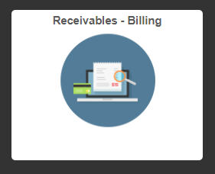
Choose Customer Request from the menu on the left. Make sure Add a New Value is highlighted, then choose the request type by using the Request Type drop down menu and click ADD.
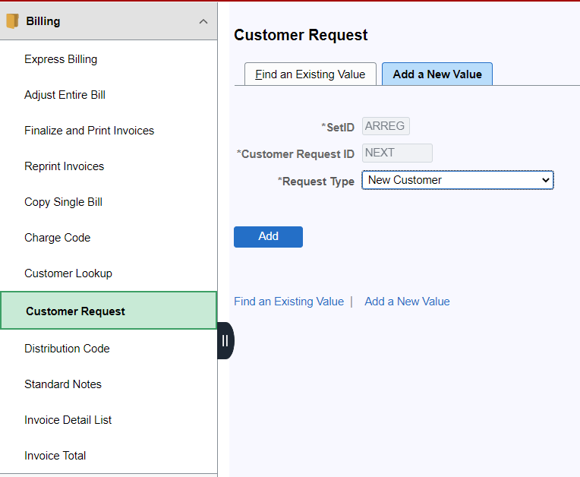
Complete the items denoted with an asterisk and click the Attachments button next to Customer Contact Info to add an attachment.
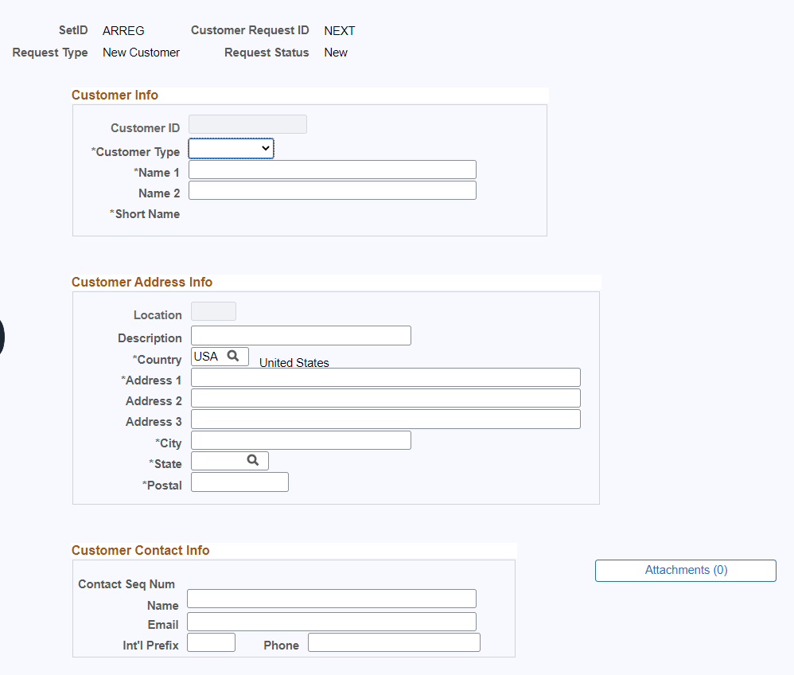

You will be directed to this screen where you will click on Add Attachment.
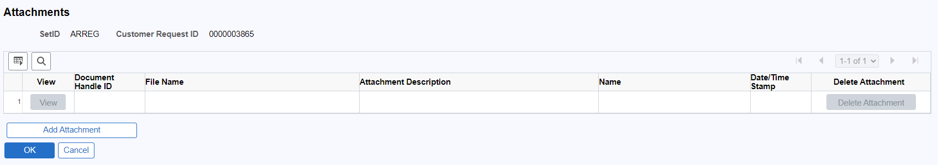

A box will pop up that will allow you to browse for your attachment by clicking on Choose File. Find your attachment and click Upload.
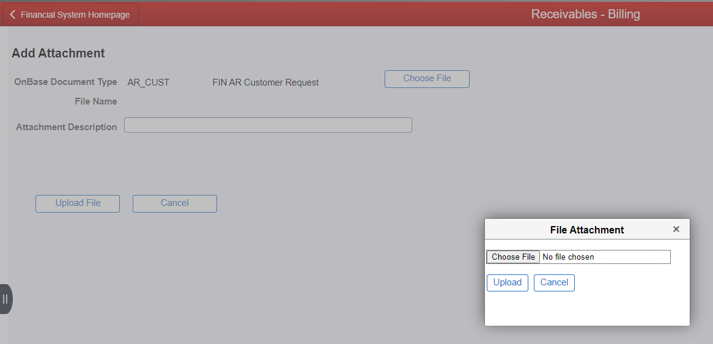

Add a description to the Attachment Description field to identify your file and then click Upload File.
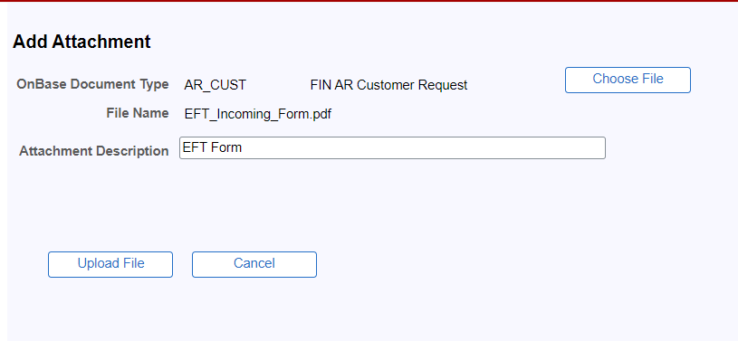

Your attachment will then appear on your request. You can click View to open and view the attachment. You can also click Delete Attachment to remove the file or add any additional attachments if needed. Once you are satisfied with your attachment(s), click OK.
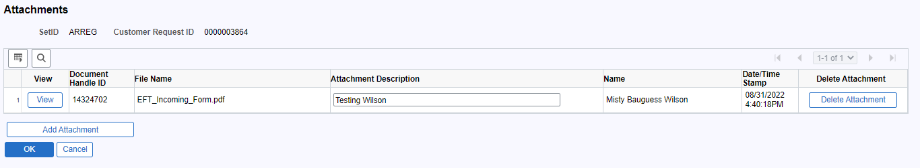

You will be returned to your request screen and will see that the Attachments button will show the number of attachments included in your request in parentheses. You can click the Attachments button at any time prior to approval to return to the attachments screen to view, add or delete attachments.
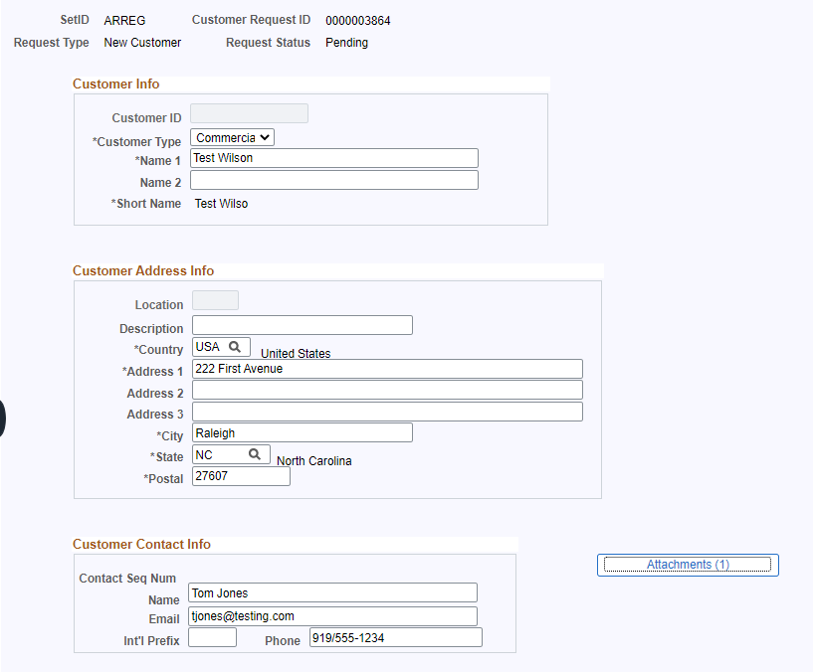

Once you have submitted your customer request, you can still view, add or delete attachments until the request is approved. Once the request is approved, you will only be able to view your attachments.

If you have issues with adding, viewing or deleting attachments, please reach out to Accounts Receivable in the Controller’s Office by emailing accountsreceivable@ncsu.edu.

