BILLING UNIT

PROCESS AND PROCEDURES

NC STATE UNIVERSITY

Revised November 09, 2015

INTRODUCTION
Billing units will enter billing information into the Financial System one of two ways: (1) into the Financial System directly (Online Billing) or (2) through an interface from the billing unit that will feed data into the Financial System in batches. The following instructions will cover:
- Entering invoices
- Modifying invoices
- Inquiring invoices

GETTING HELP

There are several methods available if you need assistance in Billing and Accounts Receivable.
If you need Technical assistance (e.g. I can't get to my screen, my password doesn't work, etc.), please use one of the following methods:
- Send an e-mail message describing your problem to: ETSS_help@ncsu.edu
When sending an e-mail message to the ETSS Help Desk, you will receive a return e-mail notification from the ETSS Help Desk acknowledging the receipt of your e-mail. Your problem ID number will be listed in the return notification. E-mail, rather than via phone, is the best way to contact the Help Desk initially.
- Call the ETSS Help Desk at 513-1178
When reporting a problem to the Help Desk, you will be given a problem ID number. You should record this number for use when contacting the Help Desk regarding further status on your request for assistance.
If you have a question specifically about Billing or Accounts Receivable (e.g. "I entered information in, but it isn't there when I check. What do I do?" or "How do I inquire about a specific invoice?"):
- For Billing questions, contact Accounts Receivable at 515-2159

TERMINOLOGY
The following key terms and definitions will be helpful when using Billing and Accounts Receivable:

Billing Business Unit | Billing Business Unit  Billing Business Units are used to track invoice transactions across the various lines of business.  Departments are responsible for entering charges, notes, and message codes for student and campus customers.
AR Business Unit | AR Business Unit  Accounts Receivable Business Units are used to track all invoice, debit and credit transactions..
ARREG | ARREG  AR Business Unit and SetID to which all the Non Student Billing Units feed information. Represents AR Campus.
Distribution Code | Distribution Code  Distribution Codes represent specific chartfield strings. A chartfield string consists of Account, Fund, Organization, Program, Sub-Class and Project/Grant. Most Distribution Codes are 10 digits long and formatted as PPPPPPAAAA where PPPPPP is the Project/Grant and AAAA is the last four digits of the Account. Where the Project/Grant includes a Phase, the Distribution Code is formatted as PPPPPPHHAA where PPPPPP is the Project/Grant, HH is the last two digits of the Phase and AA is the last two digits of the Account.
Account | Account  An Account describes the nature of a transaction. An Account is classified as an Asset, Liability, Equity, Revenue or Expense type. The Account is an object code associated with the AR Distribution Code. The numbering convention for Accounts is as follows:  - Asset – account starts with 1  - Liability – account starts with 2  - Equity – account starts with 3  - Revenue – account starts with 4  - Expense – account starts with 5

Customer ID | Customer ID  Customer ID is used to identify individual Customers.
Item | Item  An Item is the result of an individual transaction within the Accounts Receivable module. The Item ID identifies each transaction and must be unique. For Bills created in Billing and ‘sent’ to AR, the Invoice ID becomes the Item ID. The Item ID is system generated when a transaction is created through the Payment or Maintenance Worksheets. When a debit or credit transaction is entered manually in AR Pending Item, the Item ID is manually entered. Often the terms Item and Transaction are used interchangeably.
Online Pending Item Group | Online Pending Item Group  Billing creates Online Pending Item Groups in AR when the Load AR Pending Item process is run. In this case, the Group represents a group of Billing transactions.
Deposit | Deposit  A Deposit is a group of Payments received by one or more Customers.  When a Deposit Group is created, a Bank and Bank Account is designated, and upon saving the group a unique system generated Deposit ID is assigned.
Receivables Post Status | Receivables Post Status  The Receivables Post Status is shown on a number of Inquiry and Update pages. Unposted: have not run the receivables posting process. Posted: posting process has run successfully. Error: the page was saved but there was an error that needs to be corrected and the data will not be available for posting until the error is corrected.
Item Life Cycle | Item Life Cycle  Item ID - Invoice/Bill that is assigned by the system.  The Item Life Cycle can be illustrated as follows:  - A bill is entered in the Billing system. When the invoice is saved, it is assigned an Invoice number. If there are no errors, it is ready to be posted and loaded into the Receivables system, which will post the accounting entries to General Ledger once payment of invoice has been received and applied.  - A Payment is received and is entered into the Accounts Receivable system. Each Payment is entered in a Deposit Group and is applied to the Customer’s Account or to individual Items through the Payment Worksheet. Once Items and Payments are ‘applied’, they are ready for Receivables Update to post the items and update the Customer’s Account Balance. When the Payment is posted, it is ready for AR Journal Generation, which will post the accounting entries to General Ledger.
Online Pending Item | Online Pending Item  In Receivables, item entry is defined as entering invoices, debit memos, and credit memos. When you enter pending items online, you enter control information and detailed information about each item.
Line Item | Line Item  A charge on an invoice/bill. A bill may consist of several different lines (charges).
Wild Card | Wild Card  A Wild Card is a character used to aid in searching. For example, when searching for Customers, if we use %K, this would give us all the customers with ‘K’ as part of their Customer name.
Scroll Bar | Scroll Bar  A Scroll Bar is used to move through data rows where you have multiple occurrences of data for an effective-dated field or a group of fields. Some pages have more than one Scroll Bar, each one controlling a block of information. The height of the Scroll Bar spans the block of information it controls. Usually there is a box that frames each block of information.

ENTERING BILLING DATA
Customers are set up so that charges may be applied to their accounts. Charges can be applied one of two ways. The first is bill entry through a billing interface where a department (Billing Unit) uses another application or system to enter charges and then downloads this information. The second is the manual method of entering billing data.
Depending on the level of security assigned to your ID, you may or may not have access to enter all information covered in this section.

CUSTOMER SEARCH BY NAME
The first thing you need to prior to entering a bill is the customer number(s). This is done by doing a Name Search to find the customer ID under the Customers menu item within Financials or you may look up the customer ID once you are in the Billing module. Note: If a customer ID does not exist, please contact the Accounts Receivable unit for further instructions. Their phone number is 515-2159.
- Navigation
- Select - Financial Systems, Customers, Customer Information, General Information.
- SetID = ARREG
- Name 1 = Enter the name of the individual for which you are performing a Name Search. Enter first name first, middle initial, then last name. If information is not found, simply enter the first name and press Search. Scroll through list until individual is found. (Ex. entering Robert and pressing Search will bring up customers where the first name is Robert)
- Press Search
- Select that individual directly from the list by clicking on their name
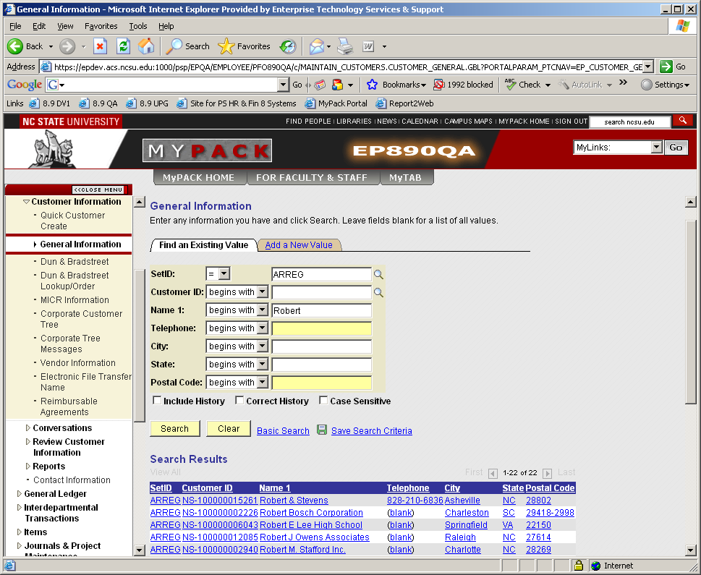
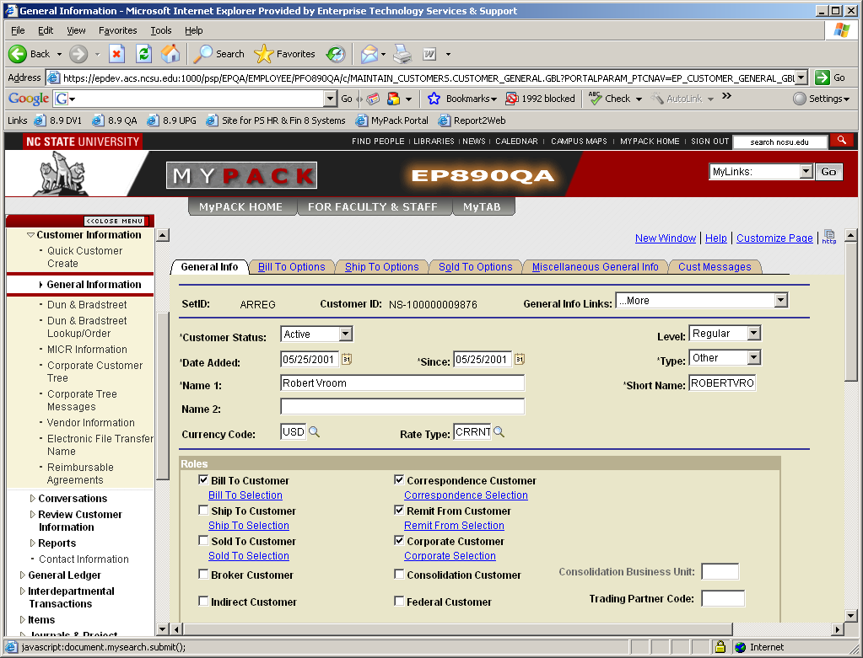

vi) Review the desired information by selecting the appropriate tab in the page group. There are several tabs to select from depending upon your security access. Once you have located the correct customer, scroll to the bottom of the General Info tab. This will provide all the address information for the customer.

ENTERING A CHARGE
The steps below explain how to enter charges for a specific customer.
- Navigation
    - Select Financial System, Billing, Maintain Bills, Express Billing
    - Select the Add a New Value tab
    - Business Unit = Enter your department’s Billing Business Unit ID
    - Invoice = NEXT (always)
    - Bill Source = Value will default in. If your department has more than once source, click on the magnifying glass and choose the appropriate source.

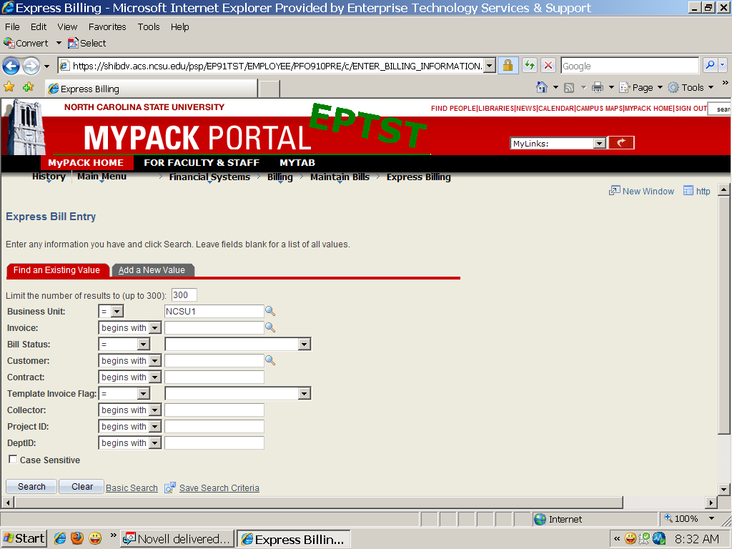

    - Customer = Enter the Customer ID. If you do not know the Customer ID, you can perform a Customer Search two ways. 1) Use the Customer lookup (magnifying glass) on the “Add a New Value” page or 2) use the Customer Search by Name from the previous page.
    - Click Add

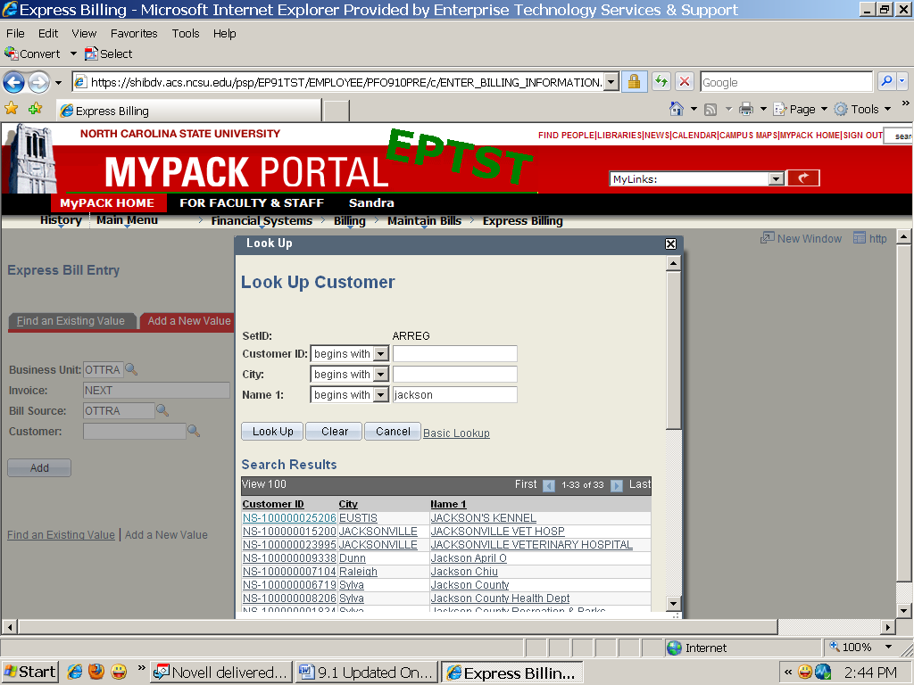

- Billing General
    - Bill Status = Now automatically defaults in as ‘RDY’
    - Cycle ID
iii) Dept = After the billing information is entered, the department ID will be populated once the invoice is saved. (Verify that the department number is correct – it can be changed if necessary – Alert AR if an incorrect department number is being populated)
    - Payment Terms – defaults to Net 30, but can be changed.
    - Bill Source = Verify - especially if a business unit has more than one bill source.
    - Biller = Enter the appropriate biller id if not defaulted in (use the magnifying glass icon to view the list of available billers).

Verify Address Information
    - Name = Person’s name whose attention the invoice is to be address to (if applicable)
    - Location – Enter the location number noted when the customer information was retrieved. If you forgot to note the location number, click on the magnifying glass to select from the list of locations.
    - # of Copies = select the number of copies of this invoice you wish to print. The system defaults a value of ‘1’
    - Review the data entered, correct any errors.
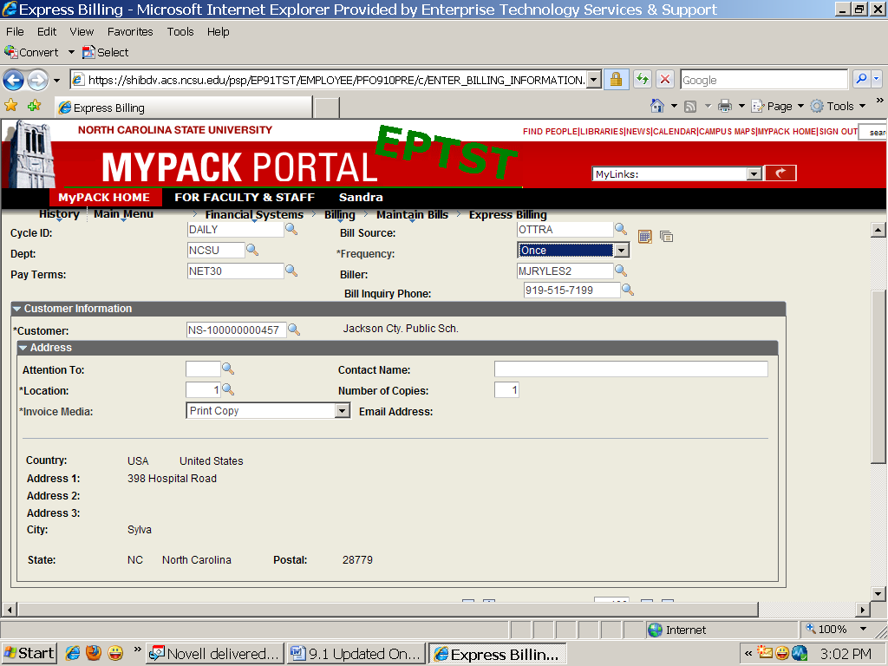
c) Bill Lines
    - Charge Code = Click on the magnifying glass to select from the list of charge codes
    - Qty = Enter quantity of items purchased
    - Unit Price = Enter in Unit Price or verify default amount is correct.
    - To add another line item, click the + (Add row) icon to insert a blank line. Complete steps i - iii from above to enter the new charge. To delete a line item, click the – (Delete Row) icon to delete a line
Rows may also be added or copied by inserting the number of “Lines to Add” or selecting the copy icon.
    - Review the data entered, correct any errors

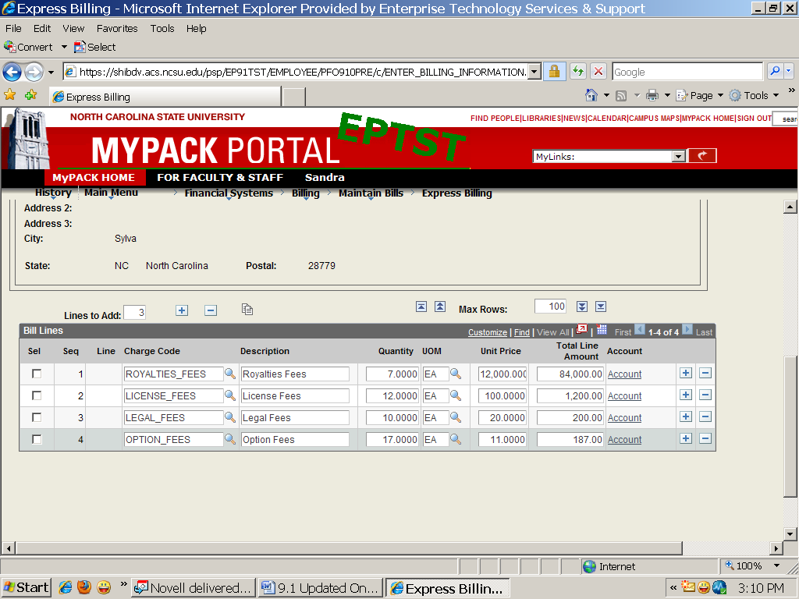

- Header Notes

Click on Header Notes on the bottom left of page

  - Header Note is used to add text to invoices. The note applies to the entire invoice and prints on the bill statement at the bottom of the invoice. The user can select from predefined standard notes or create individualized notes
  - If predefined, select that note code in the Std Note field. Note Type defaults from the Standard Note Code. The predefined text will appear in the Note Text field once you select the Std Note
  - If your note is not predefined, leave Standard Note Code unchecked. Enter the Note Text as you want it to appear on the invoice
  - If you want either the Standard Note or the note you create to be for internal use only, check Internal Only. Review the data entered, correct any errors.

Click on the Billing General Tab at the top or bottom of the page to return to previous page or to add Line Notes.

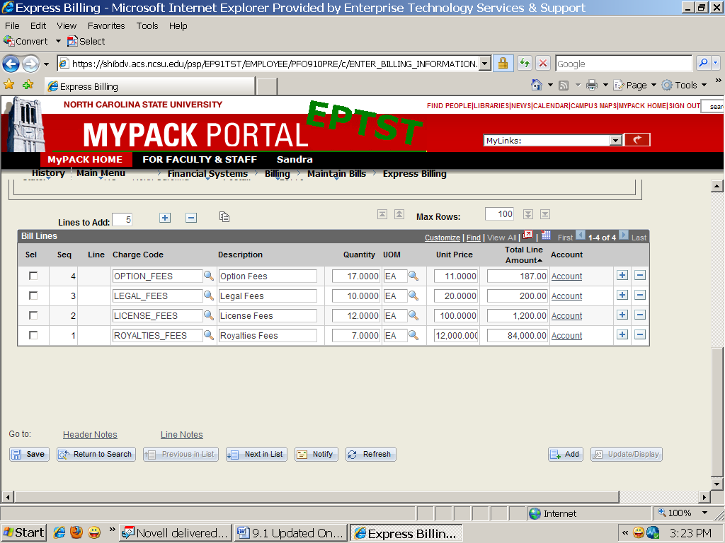

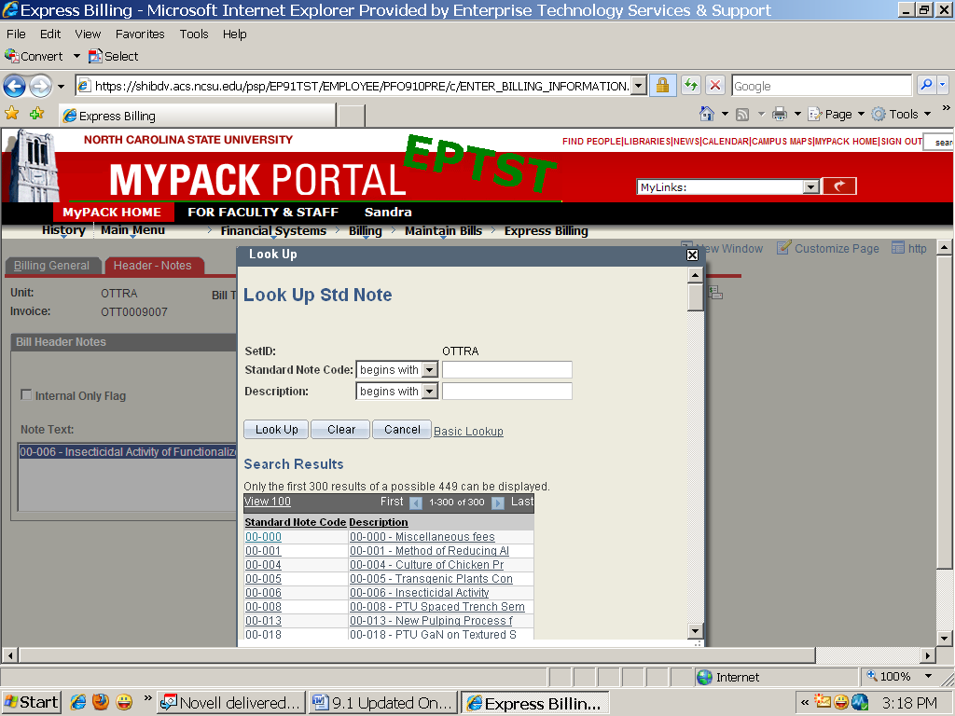

d) Line Notes

- The Line Note page is used to add text to specific bill lines on invoices. A note added on the Line Note page applies to specific bill lines not the entire invoice and prints on the bill statement. The user can select from predefined standard notes or create individualized notes.
- If predefined, select that note code in the Std Note field. Note Type defaults from the Standard Note Code. The predefined text appears in Note Text field once you select the Std Note. Go to the navigation: Financial Systems, Billing, Standard Notes to add additional notes.

- If the note is not predefined, leave Standard Note Flag unchecked. Enter the Note Text as you want it to appear on the invoice.
- If you want either the Standard Note or the note you create to be for internal use only, check Internal Only.
- Review the data entered, correct any errors. Click the Save button. The invoice will be saved and an invoice number will be assigned by the system.

Below the New Window Icon (top right) there is a Pro Forma (Preview) and a Print Invoice icon. Select ProForma
icon to review the invoice before printing.

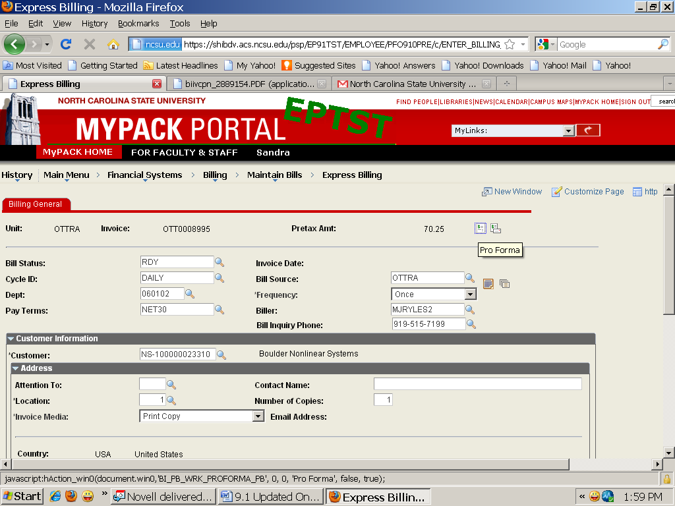

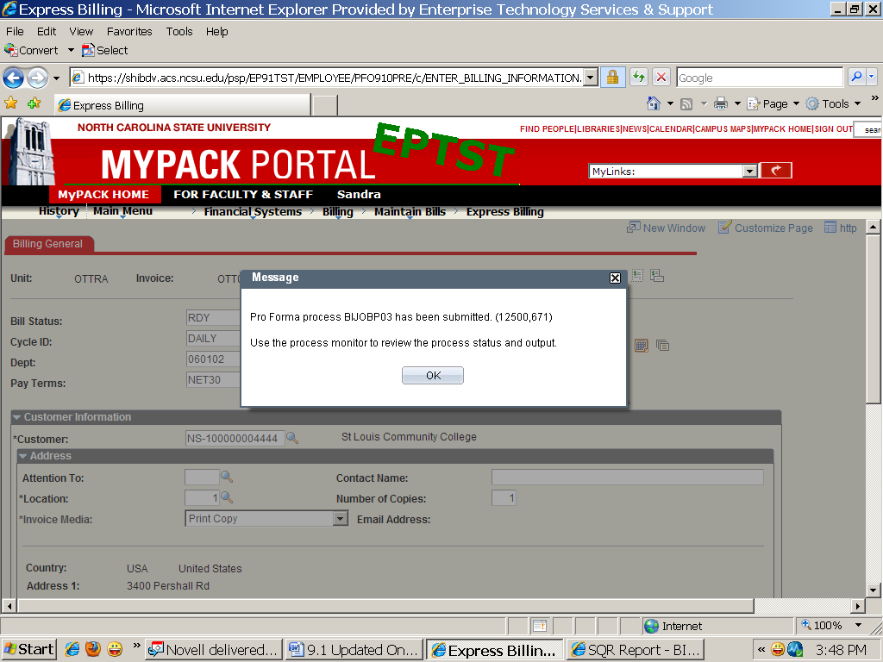

The Pro Forma (Print Preview) should appear as a crystal report.

Use the print icon to finalize and print the invoice. Completion of this step is necessary to update
Accounts Receivable.

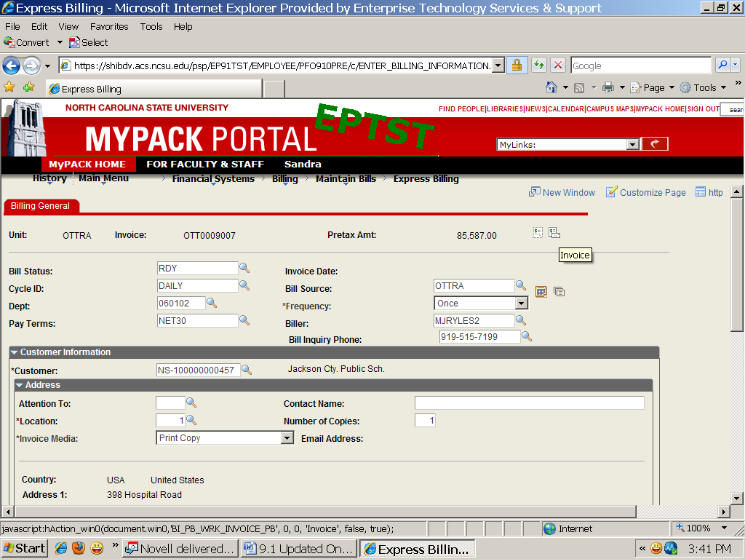

MODIFYING BILLING DATA
Charges on a bill can be modified up until the status of the bill has changed to INV by running the Finalize and Print Invoices process and loaded into the general ledger and accounts receivable. Once a bill has been processed, changes can only be made under Adjust Entire Bill - where you can credit an entire bill or credit and rebill a customer.

ADJUSTING AN ENTIRE BILL
If a bill has been processed and an invoice generated, the bill must be modified (adjusted) not changed. The steps below explain how to modify a bill by crediting an entire bill.
- Navigation
- Select Financial Systems, Billing, Maintain Bills, Adjust Entire Bill. The Find an Existing Value tab appears.
- Business Unit = Enter your department’s Billing Business Unit ID
- Enter the invoice number you want to adjust and press Search. You may also leave this field blank and press Search to select an invoice from the list.
  - Adjust Entire Bill
- Click on the Credit Entire Bill radio button. Always leave the Credit Bill set to Next so that the system will assign the next invoice number to the Credit Bill.
- An Adjustment Reason for all credits is required.
- Click the Save button. Once saved the new credit bill invoice number will be displayed and the radio button will reset back to “No Bill Action”.
- Click on the Header - Info 1 hyperlink at the right of the Credit Bill field (to view the credit)
- A new window will pop-up for the Credit bill and the Header – Info 1 page will be displayed.
- Finalize and print the invoice using the print icon. (This step is necessary to update AR)

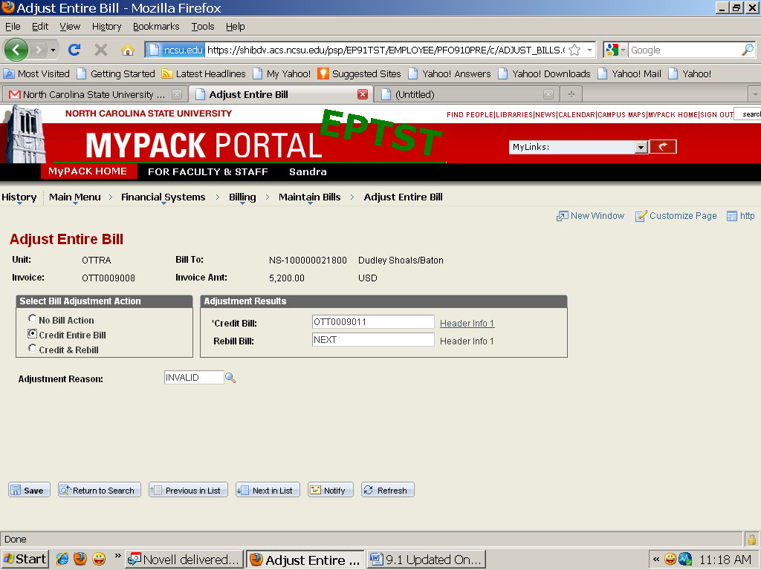

CREDITING AND REBILLING A CUSTOMER
This function will generate a credit invoice and a revised bill for the same customer.
- Navigation
    - Select Financial Systems, Billing, Maintain Bills, Adjust Entire Bill. The Find an Existing Value tab will appear.
    - Business Unit = Enter your department’s Billing Business Unit ID
    - Enter the invoice number you want to adjust and press Search. You may also leave this field blank and press Search to select an invoice from the list.
- Adjust Entire Bill
- Select the Credit and Rebill radio button. Always leave the Credit Bill and Rebill Bill set to Next so that the system will assign the next invoice number to the Credit Bill and Rebill Bill
- An Adjustment Reason for all credits is required
- Click the Save button. Once saved, the new invoice number will be displayed and the radio button will reset back to “No Bill Action”

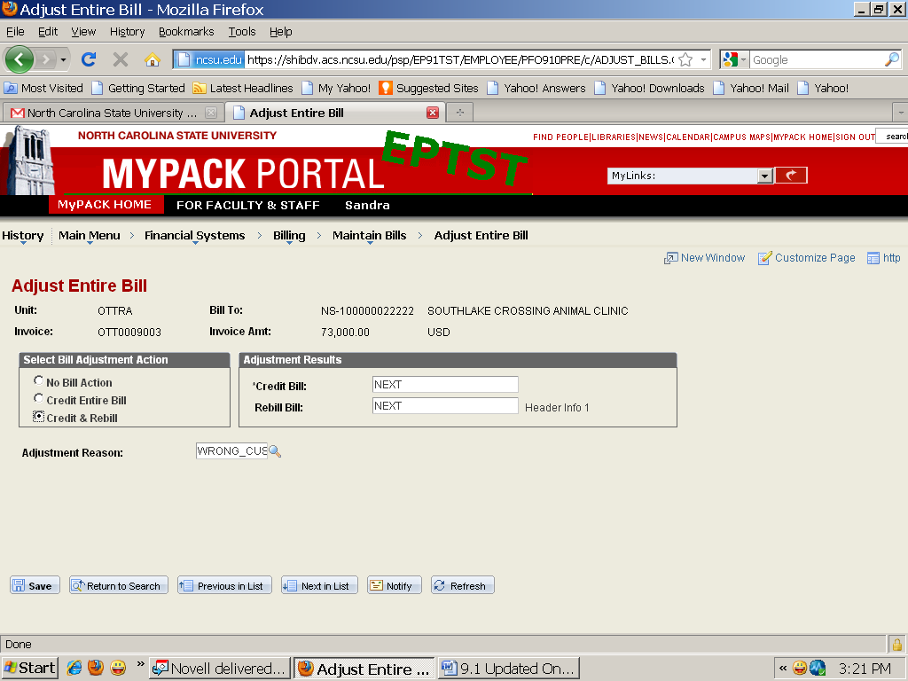

- Click on the Header – Info 1 link beside of the Credit Bill line to view the credit bill.
- A new window will pop-up for the Credit bill and the Header - Info 1 page will be displayed.
- Finalize and print the credit invoice using the print icon.

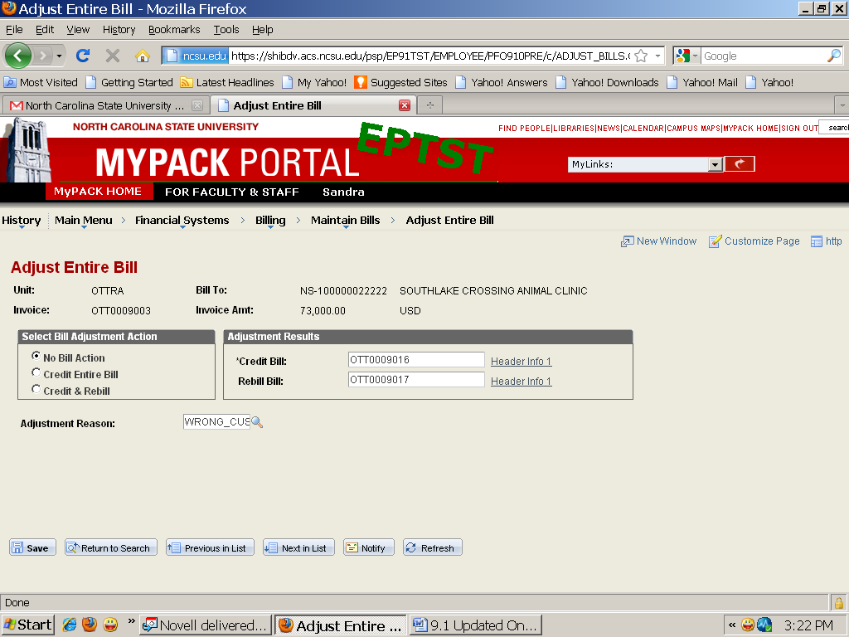

- Return to Adjust Entire Bill window and select the Header - Info 1 link beside the Rebill Bill line
- A new window will pop-up for the Rebill bill and the Header - Info 1 page will be displayed.
Header - Info 1 (for the new invoice/rebill)
- Make any required changes to the rebill on any bill entry page (ie. select a different charge, adjust or pro-rate an amount, etc)
- Click the Save button to save the changes

COPY SINGLE BILL
There may be instances in which the user wishes to create a new bill that is an exact copy of an existing bill. The steps below explain how to copy a single bill.
- Navigation
  - Select Financial Systems, Billing, Maintain Bills, Copy Single Bill
  - Copy Single Bill - The Find an Existing Value page will appear
  - Business Unit = Enter your department’s Billing Business Unit ID
  - Invoice = Enter the invoice number to be copied or click search and select one from the list
  - Click Search
  - Click on the Copy Bill radio button and click Save. Once you have saved the Selected Bill Action radio button will reset to ‘No Bill Action’ and you will have a new invoice number in the Copy Bill field.
  - Click on the ‘Go to Bill Header – Gen Info’ hyperlink at the end of the Copy Bill field.
  - A new window will pop-up and the Billing General Tab will be displayed.
  - Make any required changes - Save and finalize and print the invoice.

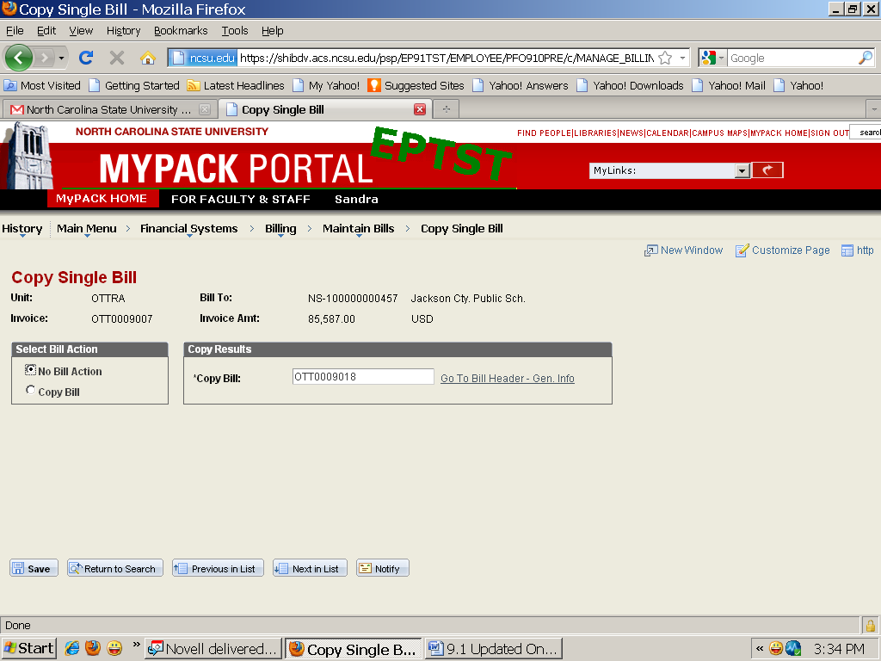

REPRINT INVOICES

Once a bill is printed, you may want to reprint it at some point in time. To reprint an invoice, do the following:
- Navigation
- Select Financial Systems, Billing, Generate Invoices, Non-Consolidated, Reprint Invoices, Find an Existing Value, type the Run Control ID and press Search.
- Select the appropriate Run Control ID from the Search Results

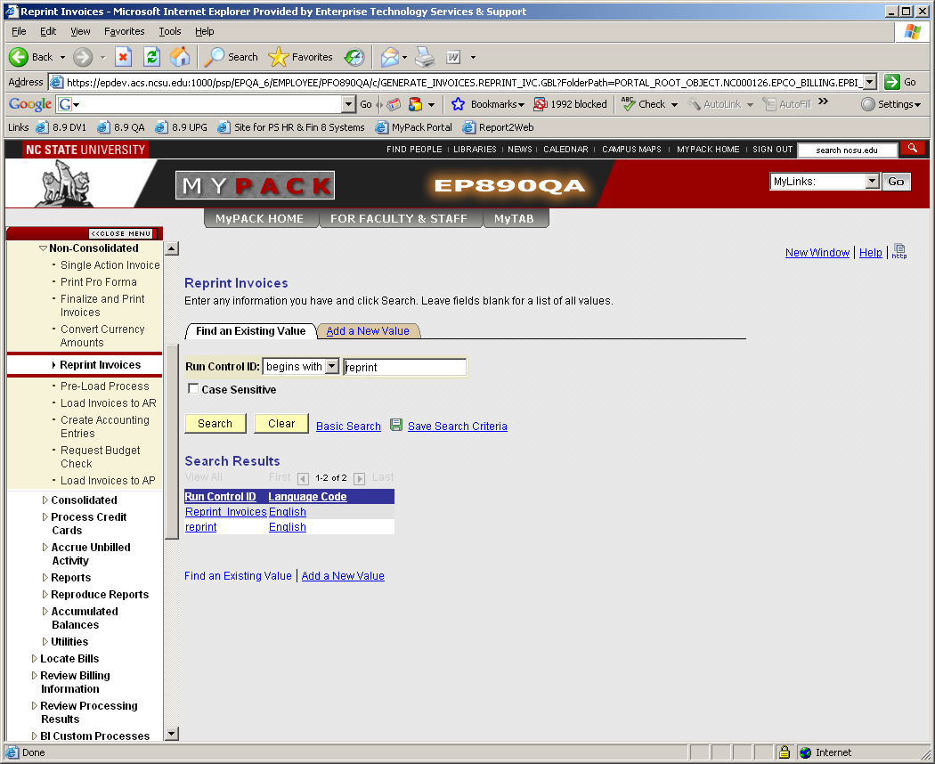

- If you do not have an existing Reprint_Invoices run control, click on the “Add a New Value” tab in order to add/create a specific run control for this process. You only need to setup the specific run control for this process the first time you access this process. In the Run Control ID: field type “Reprint_Invoices” and click add. After the initial run control setup, the next time you access this process, all you will need to do is click on the “Find an Existing Value” tab and select the appropriate run control
- The Reprint page appears

b) Reprint
  - From Business Unit and To Business Unit = Enter the appropriate billing business unit (use the magnifying glass icon to view the available billing business units)
    - Range Selection contains the parameters that will help you define the process: (Invoice ID is the most common selection for this process)
All – chooses all bills
Bill Cycle – specify any Cycle ID
Date Bill Added – specify any Bills Added On or After date
Range ID – specify a Range ID number
Invoice ID – specify the From/To Invoice range. The numbers are inclusive. To choose a single bill enter that invoice in both the From and the To fields.
Cust ID – specify the Customer. You can further qualify the customer by Bill Type or Source or both, but this further qualification is optional
Bill Type – specify any bill type
Bill Source – specify any bill source
iii) Review the page, correct any errors, click ‘Save’ and press the Run button.
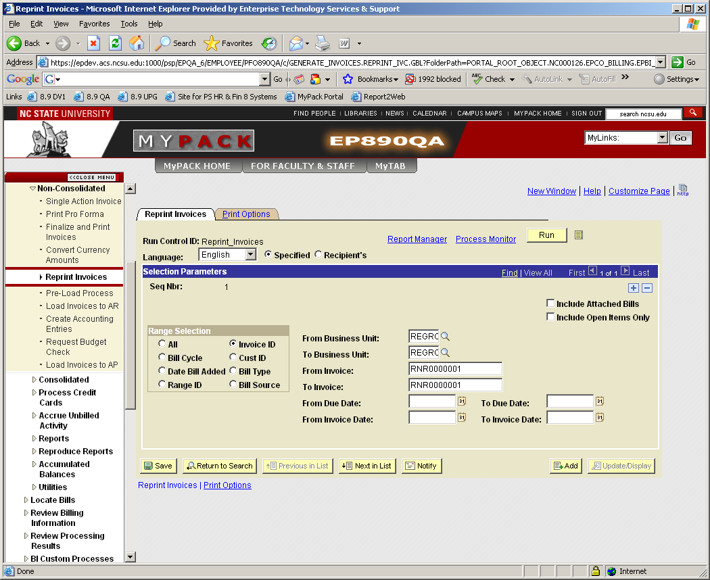

- Process Scheduler Request
- The Process Scheduler Request page will appear. The Server Name should be left blank. The system will select the server that can process the job most efficiently. The Run Date, Recurrence, Run Time and Time Zone fields should not be changed.
- At the bottom of the page, select the Print Invoice w/SQR, BIPJ10, process. Leave Type and Format set to ‘None’ and Select OK – Crystal Report of invoice will pop up and process to produce the completed invoice copy.

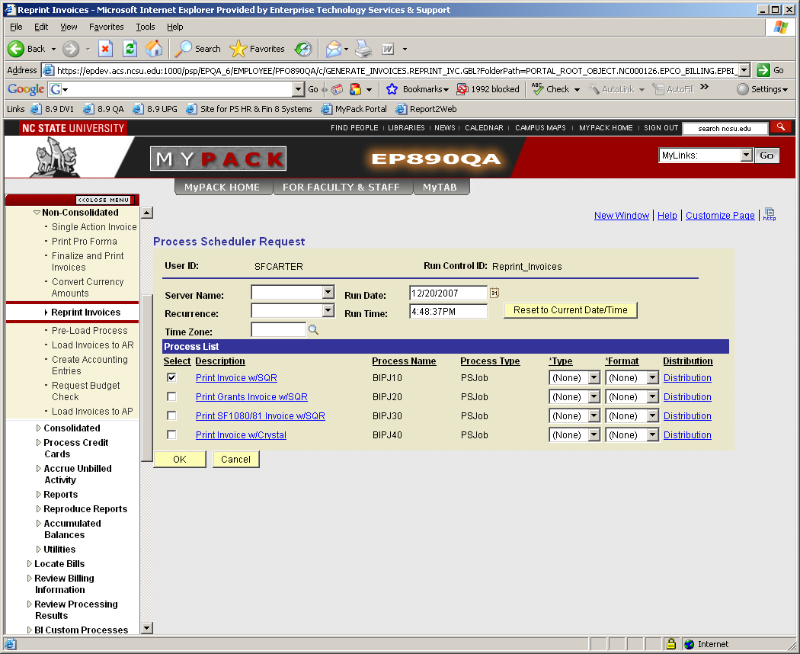

NEW REVENUE DISTRIBUTION CODE SET-UP
Distribution Codes represent specific chartfield strings. .
There is a standard format when creating a new Distribution Code. The Distribution Code is a combination of the Project or Project-Phase and the Account.
If the Project/Account is……………….. Project Account
375830 40399
Then the Revenue Distribution Code should be setup like this……………………………..3758300399
If the Project-Phase/Account is……... …Project-Phase Account
375830-06772 40399
Then the Revenue Distribution Code should be setup like this………………………………3758307299

To setup a new distribution code, do the following:

  - Navigation
- Select Financial Systems, Billing, Distribution Code, Find an Existing Value (or Add a New Value)
      - SetID = Enter your department’s Billing Business Unit ID
      - Distribution Code = Type the Distribution Code ID (maximum 10 characters)

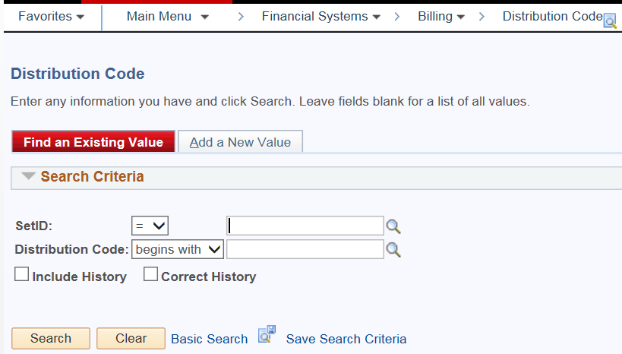

      - Click on the Search button (or on the Add a New Value tab). The Distribution Code page appears.

- Distribution Code

  - Effective Date = Type the date the Distribution Code will be effective
  - Status = Active
  - Description = Type the description of the Distribution Code (maximum 30 characters)
  - Short Description = Type the short description of the Distribution Code (maximum 10 characters)
  - Distribution Type = Select ‘Revenue’ from the drop down list
  - Unbilled AR Distribution Code = leave blank
  - Project = Type the appropriate Project. When you tab out of this field, the system will populate all the chartfields except the Account code
  - Account = Type the appropriate Account

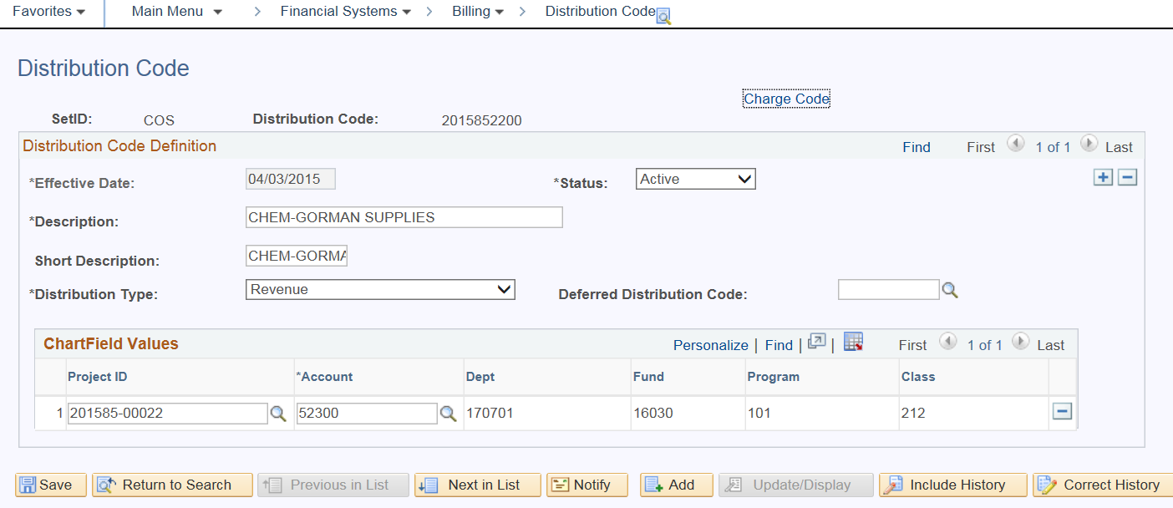

    - Review the data and correct any errors and press the Save button.

Important:

When the distribution code label (name) is the same, for example 4692508810 would be the same for 469250-05288 / 53310 and 469250-05288 / 53510, change the last digit on the distribution code to an Alpha such as 469250882A, then B if there should be an additional distribution code with the exact label (name), etc. In the chartfield value section, the complete project, phase and account is added.

ENTERING A CHARGE CODE / IDENTIFIER

Charge Codes/Identifiers represent specific products or services for which the billing unit invoices its customers. Each charge code/identifier is associated with a revenue distribution code. This mapping allows the revenue for each charge code/identifier to be posted to the appropriate chartfield string. To setup a new charge code/identifier, do the following:
- Navigation
- Select Financial Systems, Billing, Setup, Charge Code, Find an Existing Value (or Add a New Value)
- SetID = Enter your department’s Billing Business Unit ID
- Billing Currency = USD
- Billing Charge ID = Type the Billing Charge ID (maximum 18 characters)
- Select Search (or Add). The Charge Code page appears.

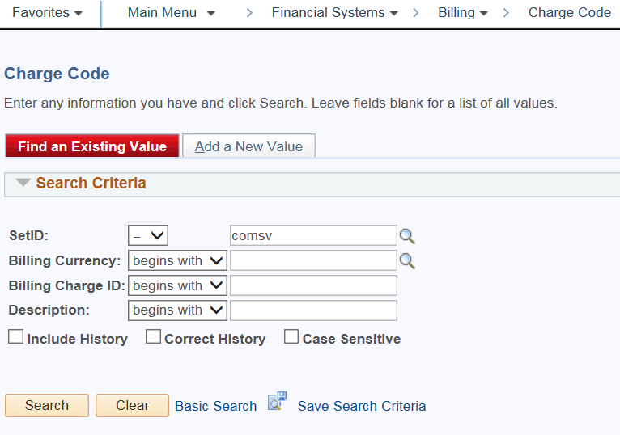

- Charge Code

- Effective Date =Type the date the Charge ID will be effective
- Status = Active
- Unit of Measure = Select the appropriate Unit of Measure unit (use the magnifying glass icon to view the available units of measure)
- List Price = Type the List Price for each unit of the product or service represented by the Charge Code. This field may be left blank
- Description = Type the description of the Charge Code (maximum 30 characters)
- Long Description = Type the extended description of the Charge Code (maximum 254 characters)
- Revenue Distribution Code = Select the appropriate revenue distribution (use the magnifying glass icon to view the available revenue distribution codes). The revenue distribution code represents the chartfield string that will be credited for each invoice created using this Charge Code.
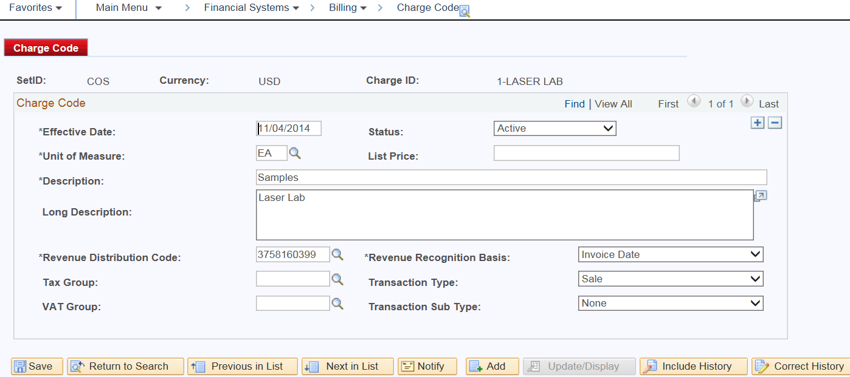

    - Review the data and correct any errors and press the Save button.

CHANGES TO CHARGE CODES

** The distribution code will need to be in the system prior to making a change to the distribution on a Charge Code.

The steps below explain how to make changes to charges.
a) Navigation

    - Financial Systems, Billing, Setup, Charge Code
    - Enter – Business Unit (SEARCH) A list of charge codes appear at the bottom of the page
    - Select the charge code you would like to change.

Anything below the bold blue line can be changed.
    - Click on the Plus Sign in the upper right-hand corner and then make any changes you need to and Save.
    - The only fields currently used are unit of measure, list price, description, and revenue distribution code.
Required fields are marked with an *. May need to select “Correct History” when making changes”.

** To change anything above the blue line, create a new charge code. Charge codes can be inactivated if necessary and will not show up in Billing; however, they will still be in the list of charge codes for the business unit.

